Chapter 6, Problem 29.

Determine C_{eq} for each circuit in Fig. 6.61.

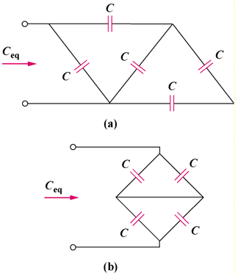

Figure 6.61
For Prob. 6.29.

